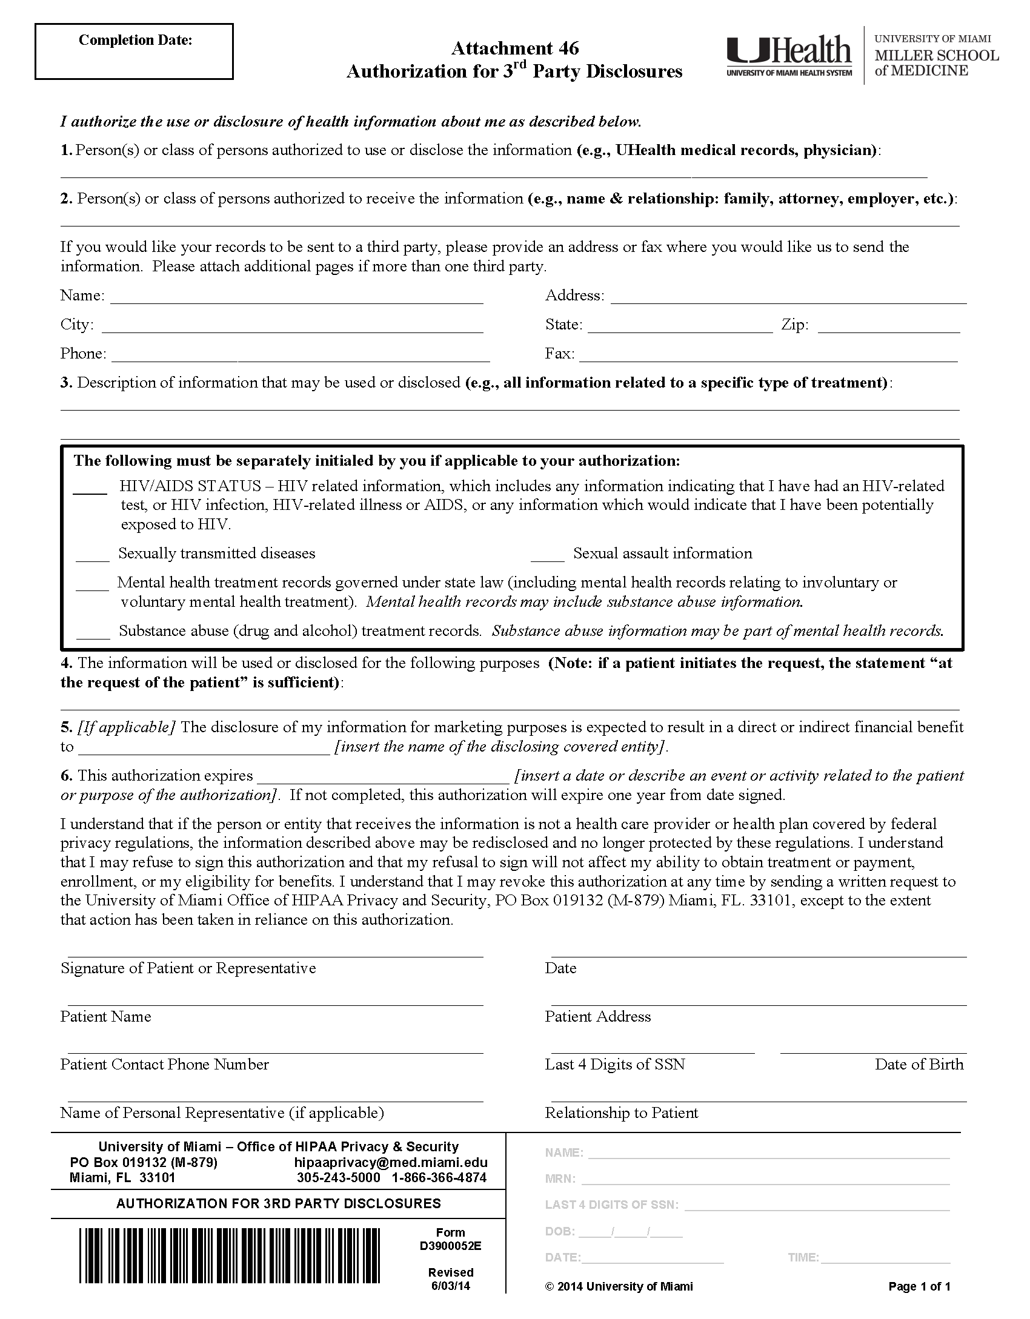
University of Michigan Hospital and Health Center
Axiom Requisition Copy Service
Okemos
(877) 886-5090
2869 Jolly Road
MI
48864
(517) 886-4116
FROM 01/01/1979 TO PRESENT: Any and all MEDICAL RECORDS, including but not limited to patient history form(s), reports, etc. pertaining to Batman SSN: xxx-xx-5555, DOB: 01/01/1979.
X
X
X
X
X
Litigation
End of Litigation
